Screenshots showing commands completed successfully and procedure descriptions are in the code:
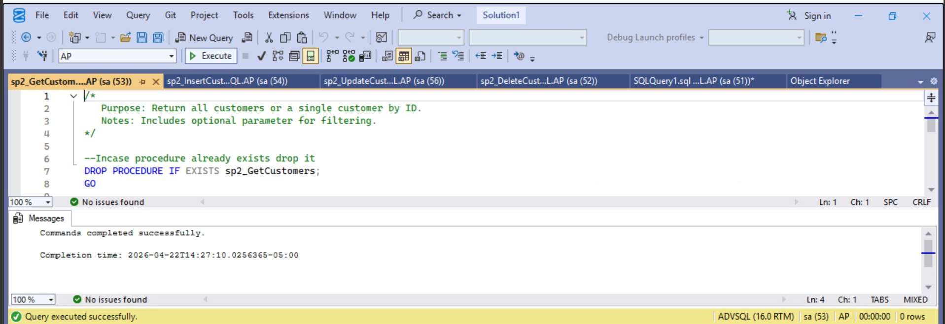
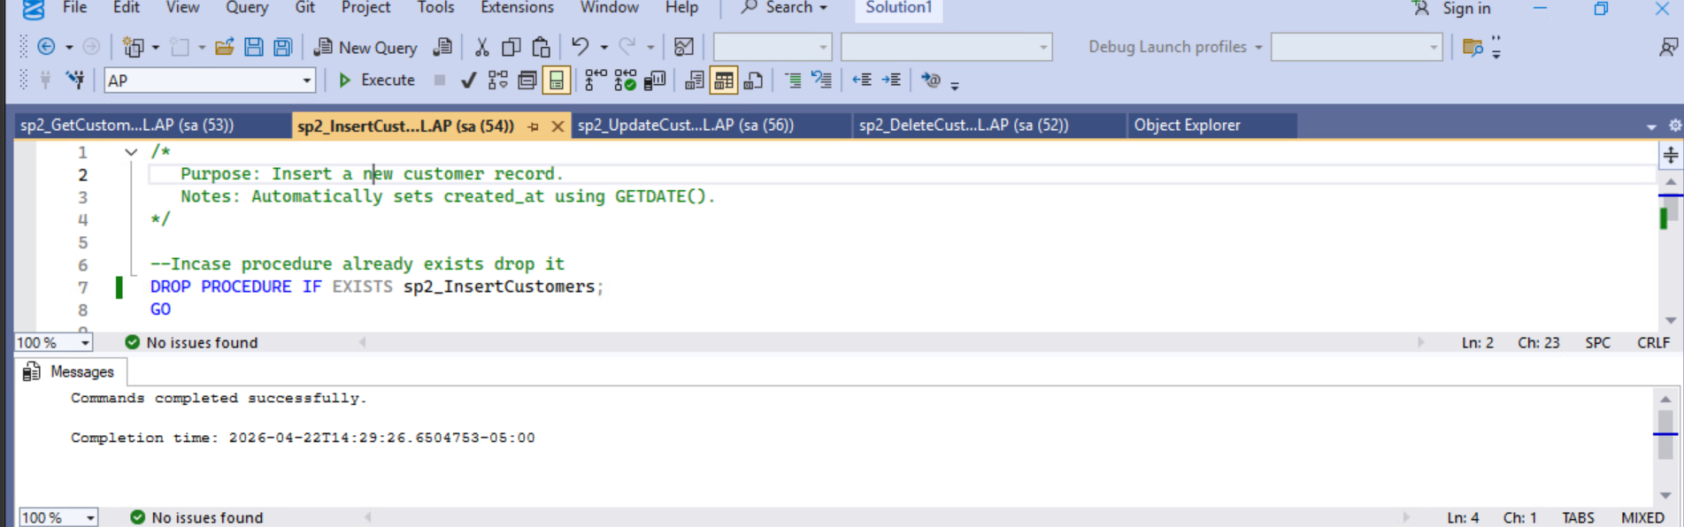
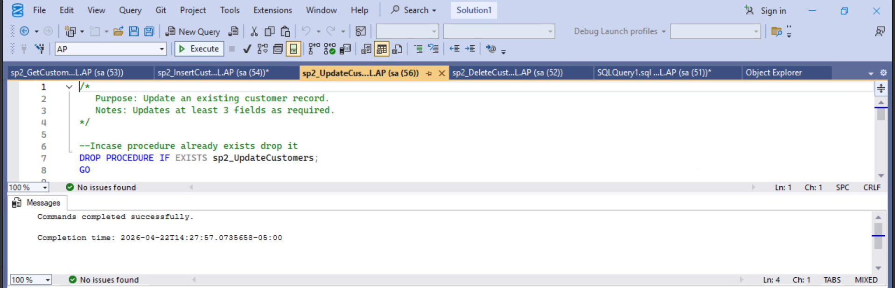
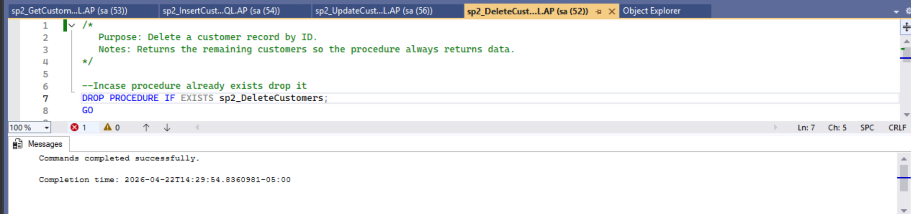

SELECT:
Code that ran:
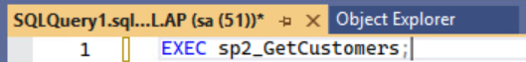
Table Screenshot 1: Rows 1-25
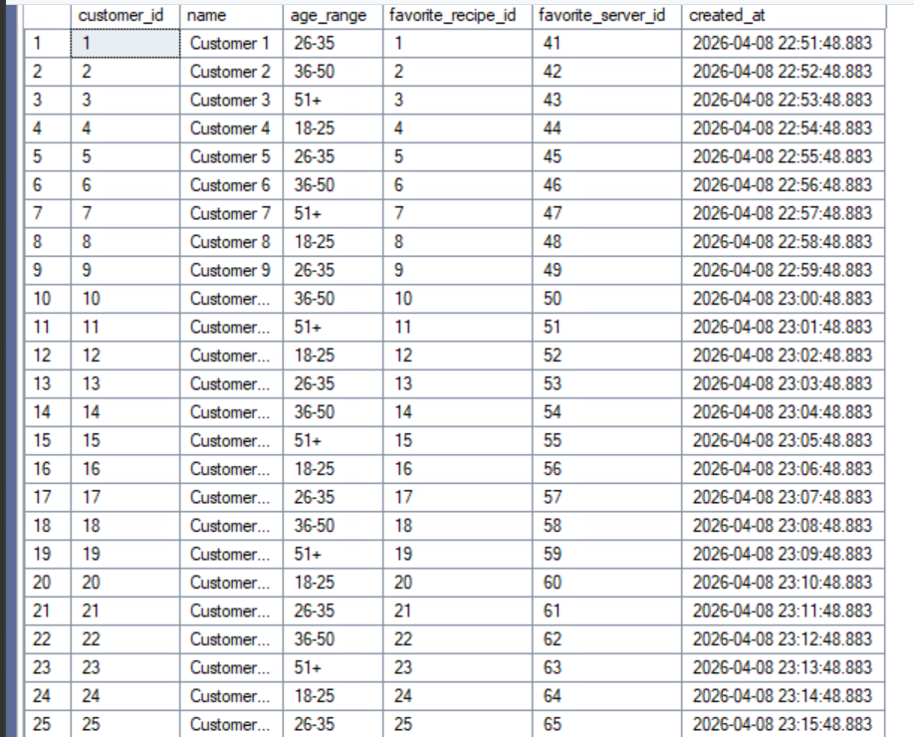
Table Screenshot 2: Rows 26-50
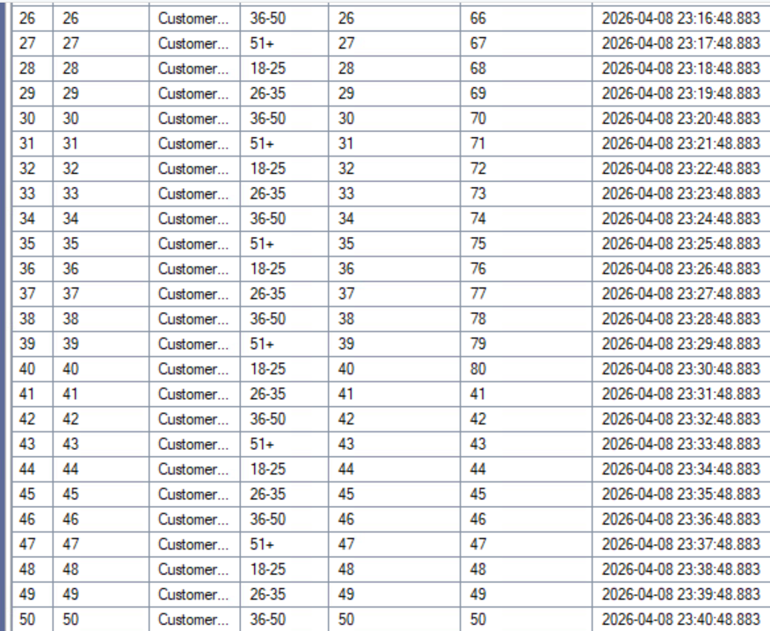
Table Screenshot 3: Rows 51-76
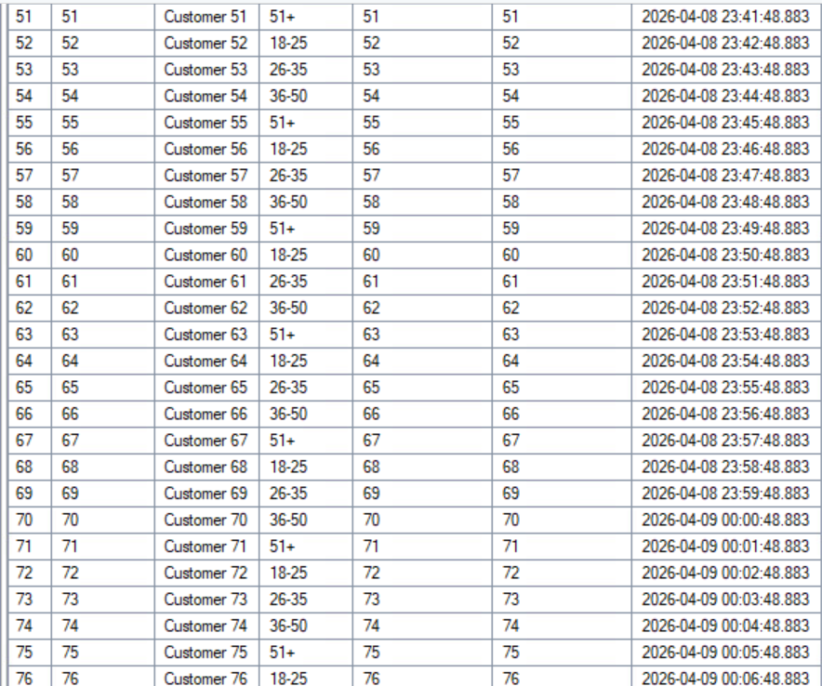
Table Screenshot 4: Rows 77-100
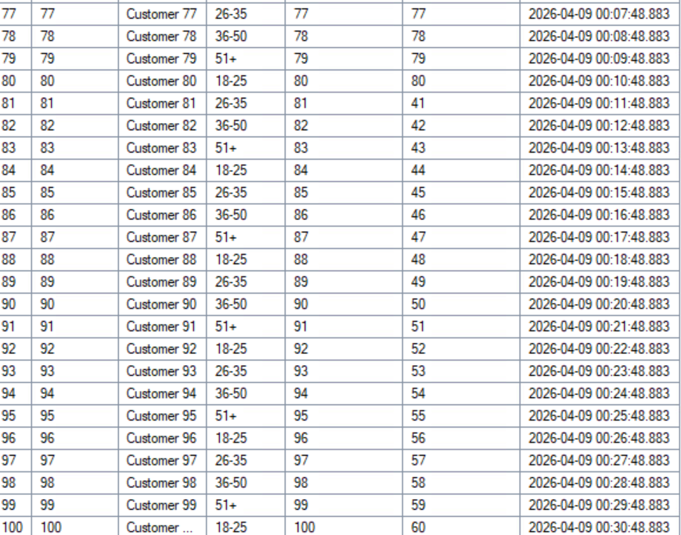

INSERT:
Code that ran:
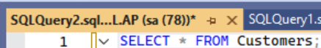
Table Screenshot 1: bottom rows are same as in the SELECT screenshots

Code than ran after:
Table Screenshot 2: New row is added
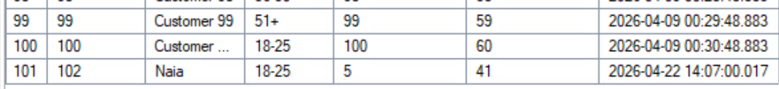
UPDATE
Screenshot 1: Code used and my row before the update
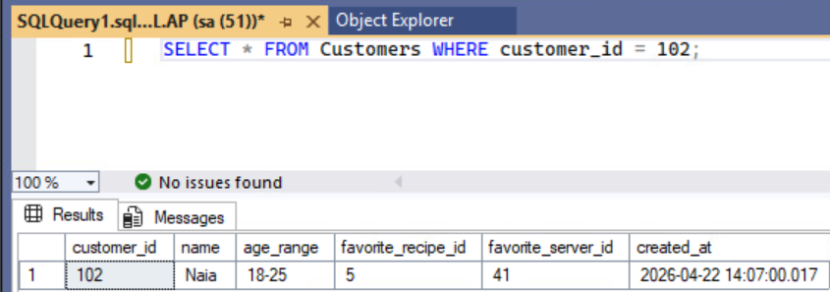
Screenshot 2: New code and updated row (age range changed)
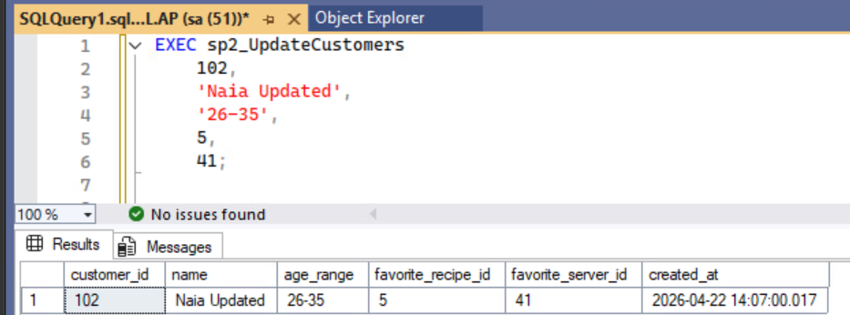
DELETE
Screenshot 1: Code used and table before deletion
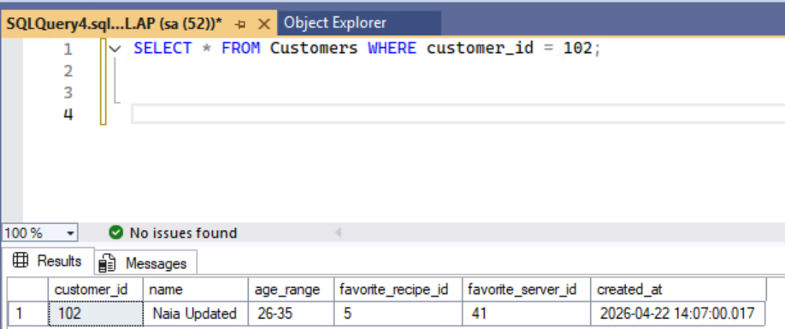
Screenshot 2: Code used and evidence that row was deleted from the table
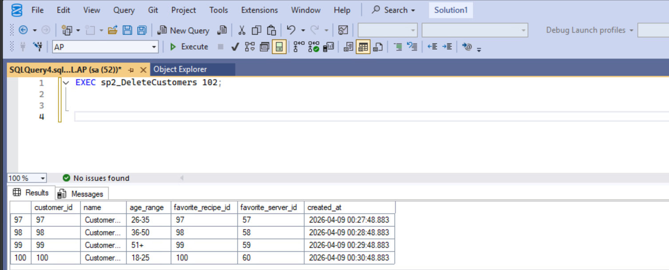
Screenshot 3: Additional screenshot showing it’s gone even when using SELECT * FROM Customers;
